Effects of Temperature / Heat
Cable performance is specified at 20 ºC. If the cabling plant is warmer than this, you will see an increase in attenuation / insertion loss. Before ANSI/TIA/EIA-568-B, this was not clear with regards to testing. It could be judged as legitimate to adjust the limit line for attenuation / insertion loss using the formula given.
This is NOT the case with ANSI/TIA/EIA-568-B.2-1 and ISO/IEC 11801:2002.
ANSI/TIA/EIA-568-B.2-1
Cables may be installed in return air plenums, in ceiling spaces, riser shafts and non air-conditioned buildings such as warehouses and manufacturing plants where the temperature can be significantly higher than 20 ºC. In order to ensure compliance with the channel insertion loss, the horizontal cable distance may need to be reduced below 90 meters depending upon the average temperature of the environment over the length of the cable, the insertion loss margin of the installed cabling, and the insertion loss temperature coefficient of the cable.
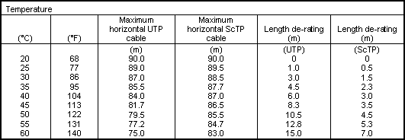
This table assumes that the channel includes 10 meters of patch and equipment cords at 20 ºC.
Example:
If a cable is installed in an environment where the temperature averaged 40 ºC over the length of the cable, then the maximum horizontal cable distance should be reduced from 90 meters to 84 meters.
ISO/IEC 11801:2002 Information technology Generic cabling for customer premises
Section 6
Performance of balanced cabling
The channel, permanent link and CP link performance specification of the relevant class shall be met for all temperatures at which the cabling is intended to operate.

